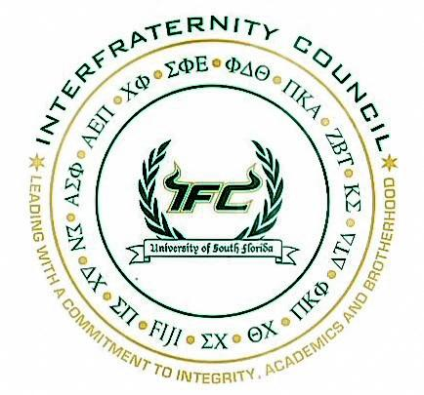
August 2, 2016.
Meeting between Panhellenic President and Interfraternity Council President to Discuss “Rush Shirt” sales between communities.

Dear Panhellenic and Interfraternity Community Members,
Following conversations with the National Panhellenic Conference Consultant Team in Spring of this year, it was brought to the attention of both the Panhellenic and Interfraternity council executive boards that certain practices here at the University of South Florida are not in accordance with the National Panhellenic Conference’s Unanimous Agreement X. This assertion was supported by the consultant team’s pronouncement, “Panhellenic women should not be purchasing and wearing men’s fraternity recruitment shirts”.
Below, you will find the Title IX agreement that exempts fraternities and sororities from having to adhere to the regulations imposed through Title IX:

Title IX, Education Amendments of 1972 (Title 20 U.S.C. Sections 1681-1688)
“(a) Prohibition against discrimination; exceptions. No person in the United States shall, on the basis of sex, be excluded from participation in, be denied the benefits of, or be subjected to discrimination under any education program or activity receiving Federal financial assistance, except that:
[…]
(6) Social fraternities or sororities; voluntary youth service organizations
this section shall not apply to membership practices --
(A) of a social fraternity or social sorority which is exempt from taxation under section 501(a) of Title 26, the active membership of which consists primarily of students in attendance at an institution of higher education.”

The Title IX exemption is what allows fraternities and sororities to remain single-sex organizations. The National Panhellenic Conference and the North-American Interfraternity Conference, along with the chapters at the University of South Florida are single-sex and focus on empowering women and empowering the development of men in our respective communities.Recruiting for any organization of the same capacity, sets the unwanted precedent that we are not single sex organizations.
In recognition of the inconvenient timing, there will be no direct repercussions for fraternity recruitment shirt sales in Fall 2016. However, the Unanimous Agreement clearly states that promoting one particular member group with t-shirts, banners, etc., during the men’s primary recruitment process is to be avoided. Thus, Panhellenic women may not wear shirts that represent fraternities during this period.
The University of South Florida’s Interfraternity council primary recruitment process begins Friday, September 2, 2016 and concludes immediately following Bid Rally on Thursday, September 15, 2016.
To be in accord with this recent understanding, Panhellenic and IFC will be exploring viable alternatives in order to further comply with the agreement established in the Title IX exemption per National Panhellenic policy. It must be stated, that the outcome must result in the eventual ceasing of t-shirts sales to Panhellenic women by IFC chapters that emphasize men’s formal recruitment.
Thank you for your time and attention to this matter. We look forward to this collaboration!

Best Regards,

Hannah B. Patterson, Panhellenic Council President
Darnell D. Octavius, Interfraternity Council President

IFC primary recruitment process dates subject to change due to unforeseen weather circumstances

